Docker Assignment
Overview of tasks : I could successfully do all three tasks. But facing some errors in task 4 which is automating through github action. Kindly check the errors and help me to rectify it. I think I have done the necessary steps of creating Action secrets , docker.yaml file etc.

Assignment Task 1
- Pull an image
What if we don’t need to run the container instead just need the image.
docker pull <image name eg: nginx>

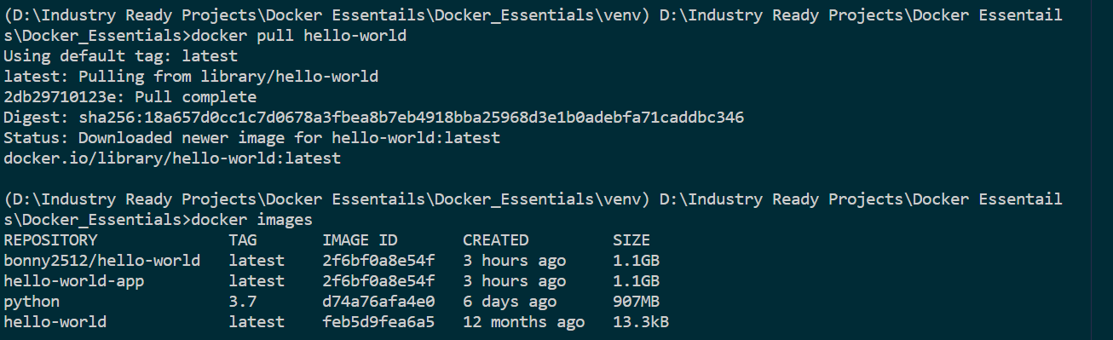

- Run an image
docker run ubuntu sleep 120 - run the ubuntu image for 2 mins then shutdown

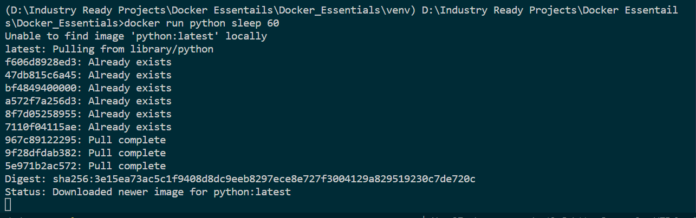

- List containers
docker ps - lists the live running containers
docker ps -a - lists the stopped and live containers

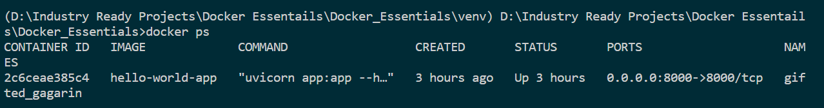
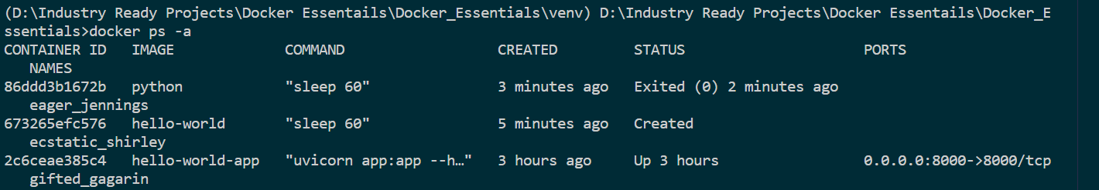

- Start a container

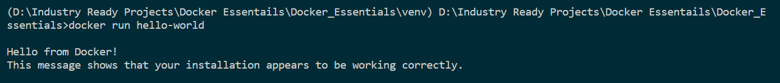
- Stop a container
docker stop < container id>

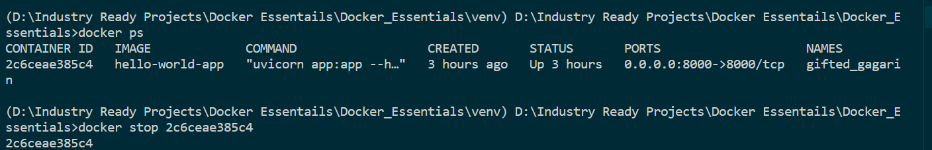

- Remove a container
docker rm <container name> - make sure to stop the container before removing

- List images
docker images

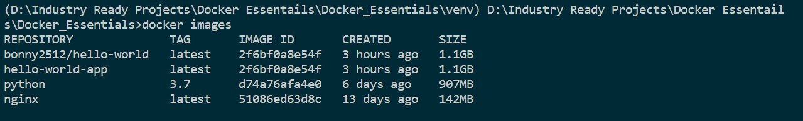

- Remove images
docker rmi <image name>
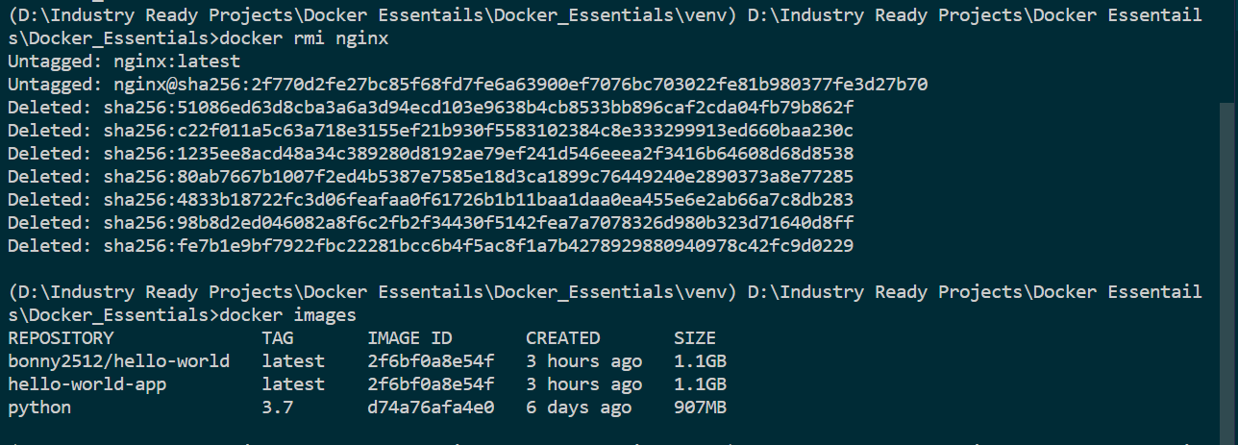

- Running commands inside a container
docker run -it ubuntu bash – This will take inside ubuntu container. We can use all linux commands then after. ‘exit’ will exit from container.
-i : interactive option - open even if not attached (ie it wont disconnected)
-t : allocate a pseudo tty (ie it command will create a pseudo terminal)
Pulling an image from docker repository
docker pull docker/getting-started

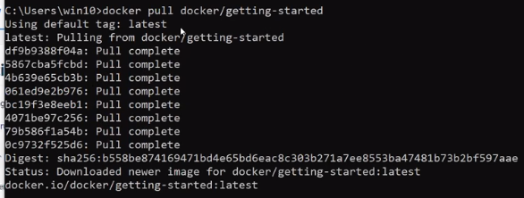

Note : we can see the sublayers inside an image getting pulled. Refer layers architecture od docker explained earlier.
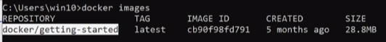
- Run the package/artifact/image
docker run -d -p 80:80 docker/getting-started
-d : detached mode ie it will run in the backend
-p : assign port. First 80 is the host port no, and second 80 is container port no. 80:80 is mapping

(Commands hereafter are shown in upcoming tasks screenshots)
Build this docker image -
docker build -t welcome-app .
-t – pseudo tty
Welcome-app is the image name I have given
Once the installation is done, check docker images and check for welcome-app in the result. Same image can be seen in docker desktop UI.
docker build -t bonny_philip/welcome-app
Now push the latest docker using docker push bonny_philip/welcome-app:latest
Latest is the version info

Assignment - Task 2
Steps:
- Pull the image
- List all the images
- Run the image

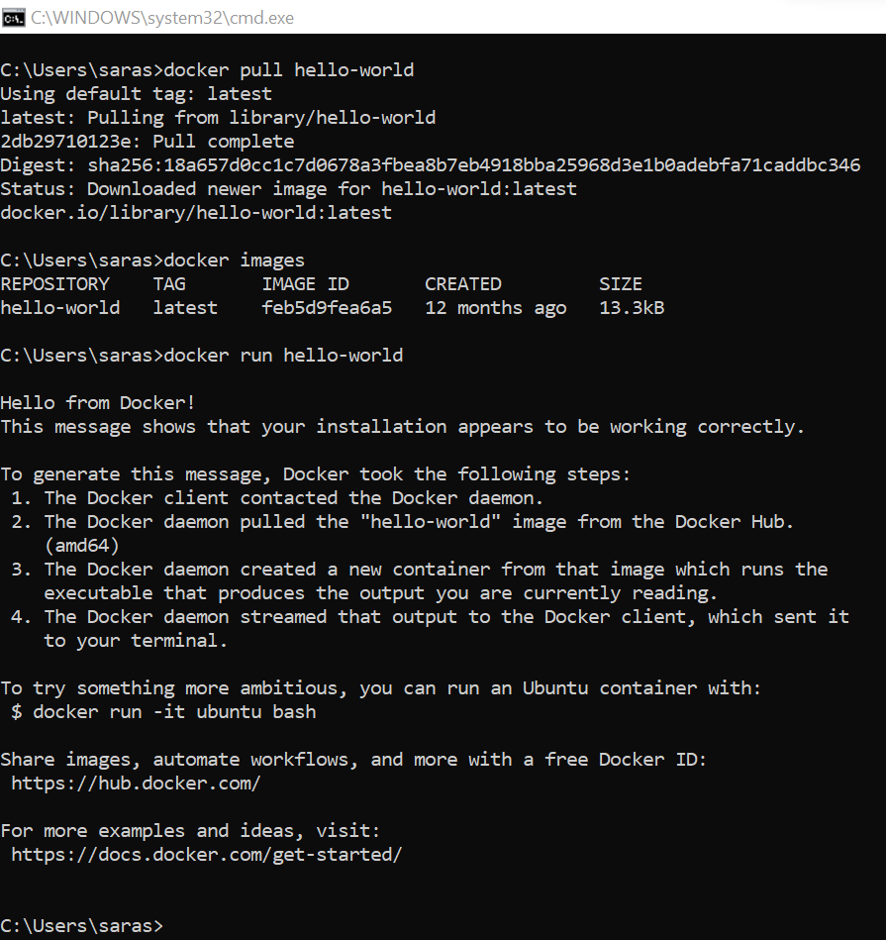

Assignment - Task 3
Steps
- Create an environment
- Install fastapi and uvicorn for enabling ASGI standard using pip install fastapi uvicorn

- Create app.py file for Hello World program using fastapi.
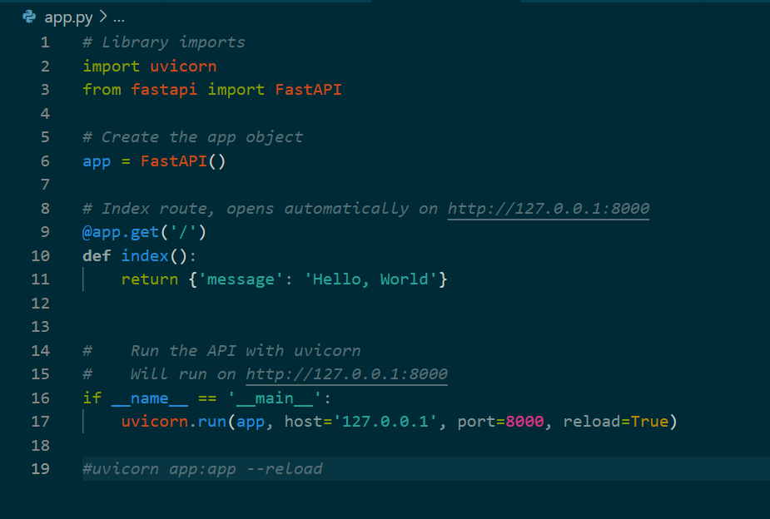
- Create Dockerfile

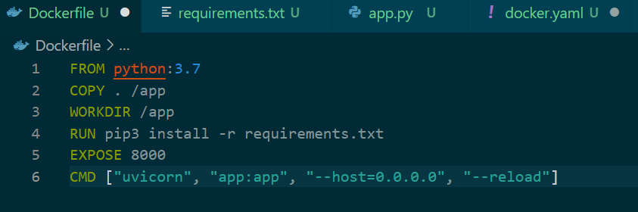

- Build the docker image

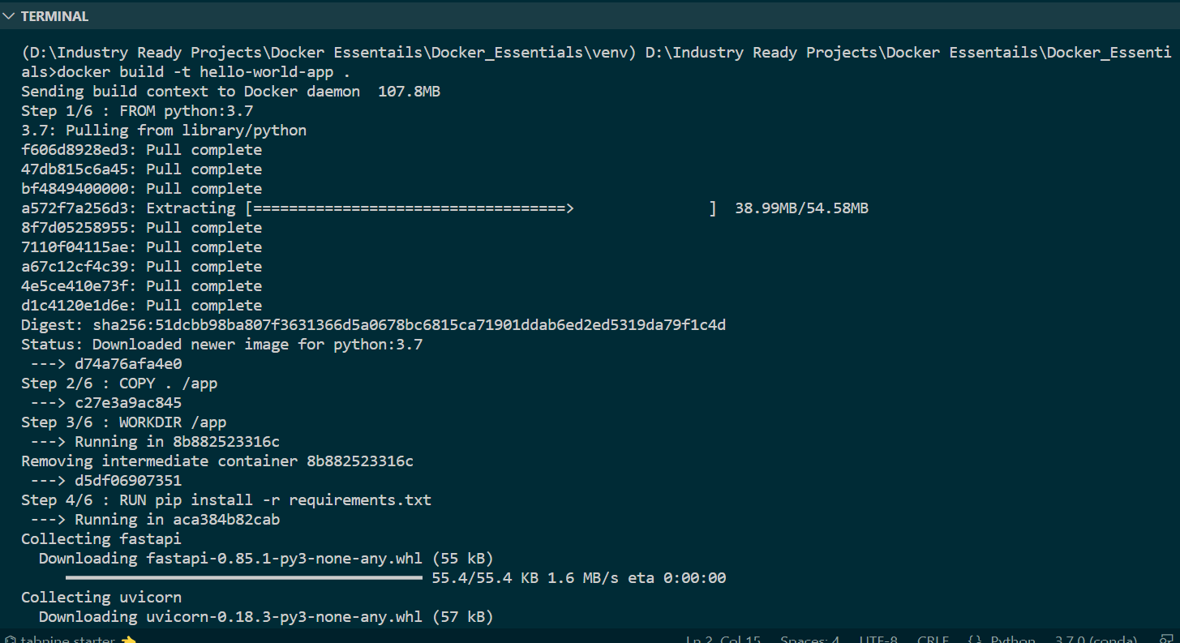
- Checking the images and run the image

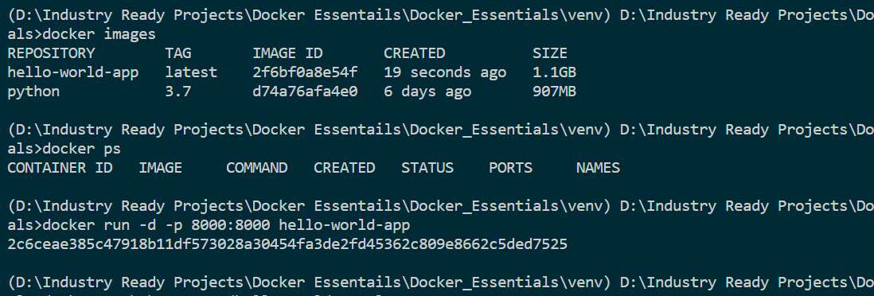

- Container starts running

- Verifying in docker desktop
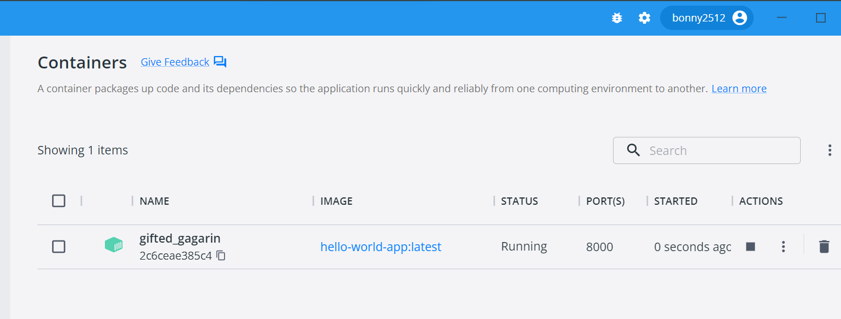

- Output

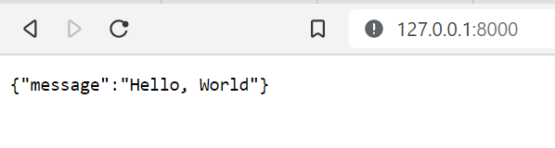

Push docker image to Docker Hub
- Build a new image with docker user id
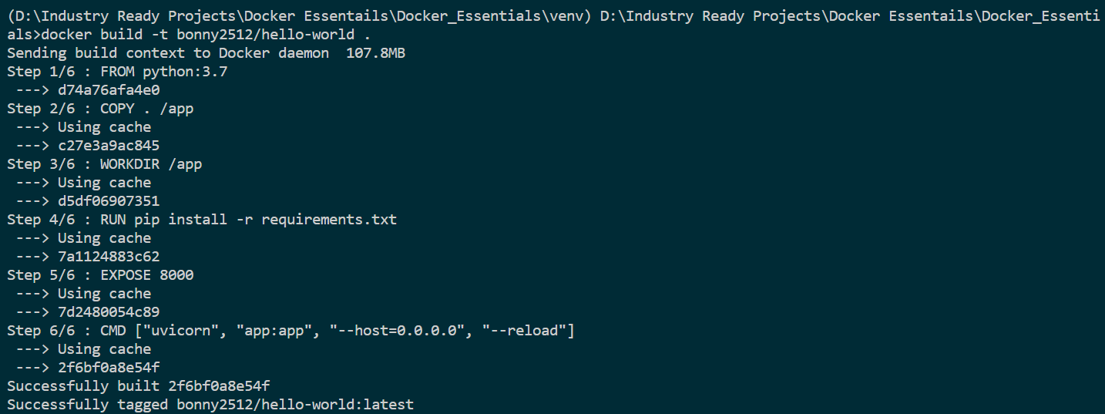

- Pushing the latest tagged container to docker hub
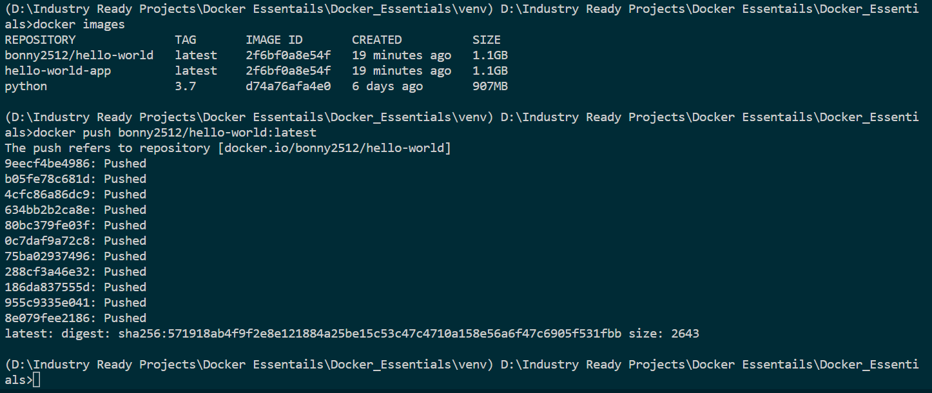

- We can see the image in docker hub

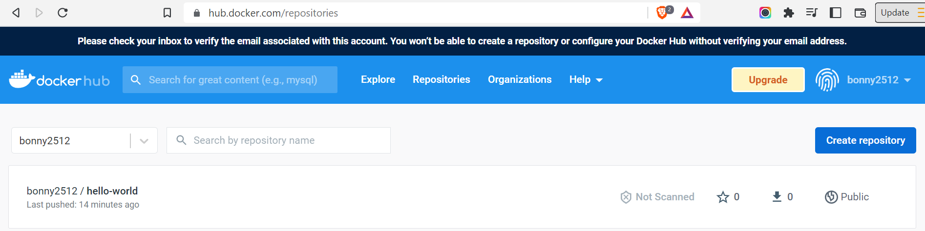

Assignment – Task 4
- Created Git Action Secrets
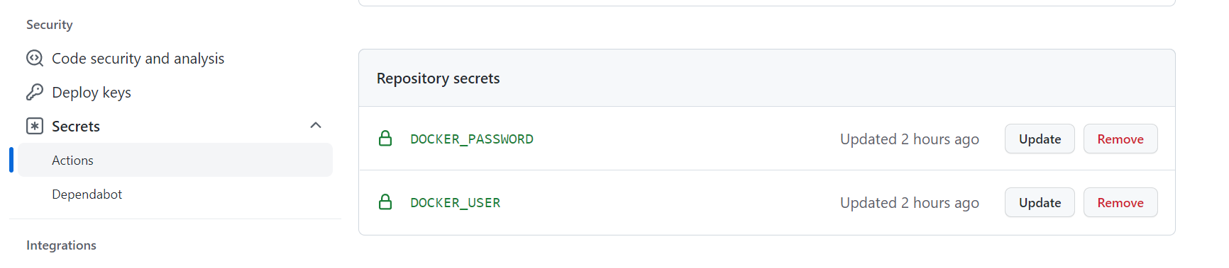

- Created docker.yaml file inside .github\workflow folder

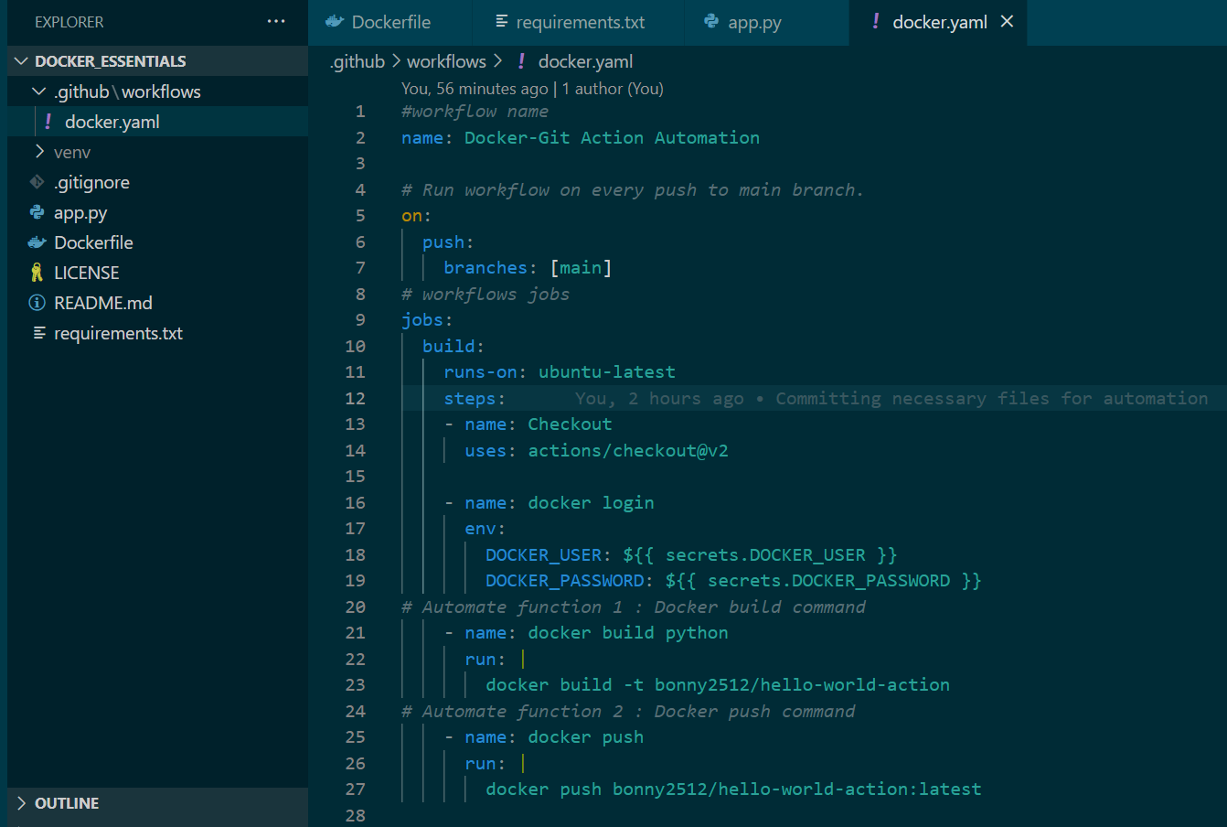

- Committed all the changes and pushed

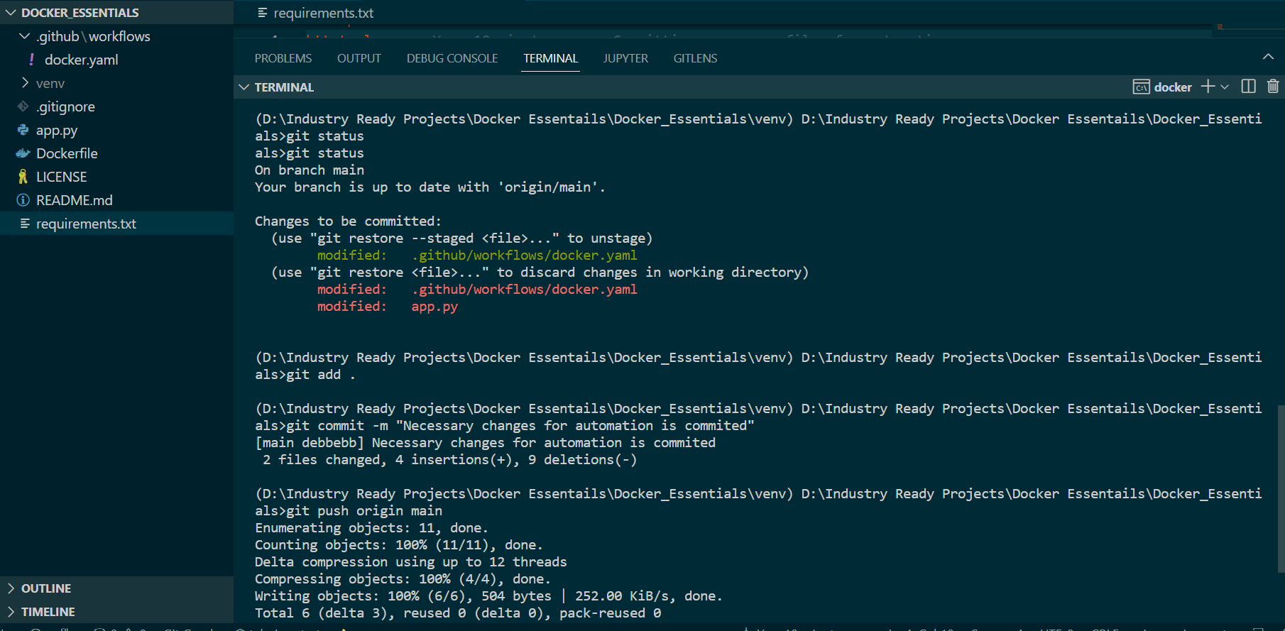

- Repository after pushing

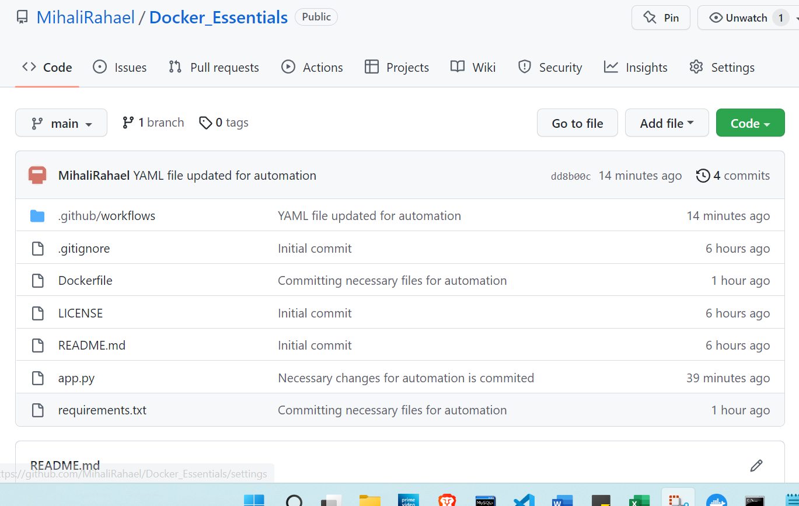

- Errors – Kindly verify and correct me
Error is showing in the yaml file. I verified it several times. Couldn’t find the error. Please help

